DIGITAL MARKETING

Assignment 1- Create a blog. Customizing the theme design and

Posting a new article with 500 words

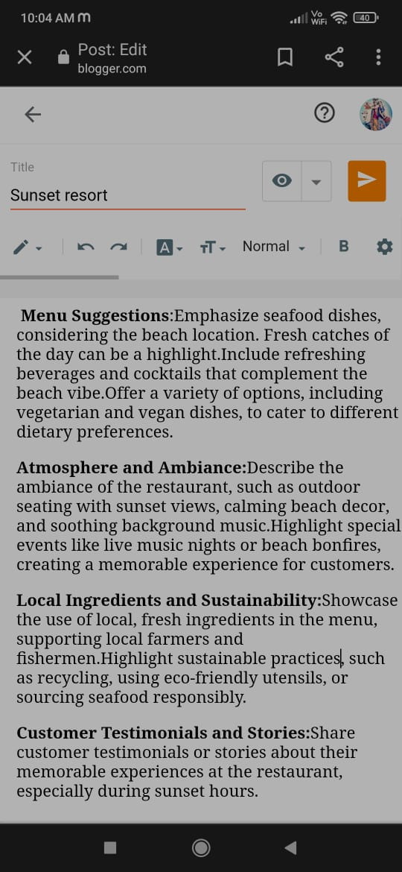

Blogger post link:

<https://www.blogger.com/blog/post/edit/6415530707360594120/4945261498181990330>

Passage:

SUNSET RESORT

"Every sunset is an opportunity to reset"

Menu Suggestions: Emphasize seafood dishes, considering the beach location. Fresh catches of the day can be a highlight. Include refreshing beverages and cocktails that complement the beach vibe. Offer a variety of options, including vegetarian and vegan dishes, to cater to different dietary preferences.

Atmosphere and Ambiance: Describe the ambiance of the restaurant, such as outdoor seating with sunset views, calming beach decor, and soothing background music. Highlight special events like live music nights or beach bonfires, creating a memorable experience for customers.

Local Ingredients and Sustainability: Showcase the use of local, fresh ingredients in the menu, supporting local farmers and fishermen. Highlight sustainable practices, such as recycling, using eco-friendly utensils, or sourcing seafood responsibly.

Customer Testimonials and Stories: Share customer testimonials or stories about their memorable experiences at the restaurant, especially during sunset hours.

Chef's Specials and Culinary Creativity: Introduce chef's specials that change based on seasonal ingredients, ensuring variety and freshness in the menu. Describe the culinary techniques and creativity behind signature dishes.

Community Involvement: Talk about the restaurant's involvement in the local community, whether through charity events, supporting local schools, or participating in beach clean-up initiatives

Social Media and Visual Content: Utilize social media platforms to share stunning sunset views, delicious dishes, and behind-the-scenes moments, engaging with the audience. Create visually appealing content, such as videos or Instagram stories, capturing the restaurant's essence during the sunset.